- We think the prospect of a quicker decline in inflation increases the chances of a consumer-led recovery in UK GDP growth taking hold in 2024. Spending fell sharply in H2 2023, but steady growth in real incomes, with some dissaving, should drive a consumer pickup this year.
- Wages recently started growing in real terms again and, with inflation set to drop sharply in the coming months, should rise further. In addition, state benefits and the national living wage will be boosted by large inflation-linked increases in April. So, we expect real income growth to remain reasonably strong, particularly for those lower down the income distribution.
- The loss of universal energy payments, ongoing fiscal drag, and rising debt servicing costs mean real disposable income growth is still likely to slow on a calendar year basis in 2024. But this will mask a gradual improvement, which should become much clearer in 2025 and 2026.
An improvement in the consumer outlook is central to our forecast that GDP growth will strengthen in 2024. We think recent inflation developments have improved the chances of this scenario playing out. Here, we focus on why we think real income growth will remain supportive and we will publish a follow-up report on why we think this, in combination with dissaving, will translate into a consumer-led recovery.
Consumer spending grew just 0.3% in 2023 and even fell by 1% in the second half of the year. This was despite real disposable income growing by around 1.7% last year. Higher wage growth mitigated the hit from high inflation with further support coming from large universal energy payments in Q1 2023, a big inflation-linked uprating in benefits, and strong employment and population growth. This suggests the consumer downturn was more a function of a greater propensity to save.
Lower inflation points to a marked slowdown in nominal income and consumption growth this year, but in real terms the picture is brighter. The withdrawal of universal energy payments, which contributed around 1ppt-1.5ppts in 2023, means real income growth in 2024 is unlikely to be as strong. But this will mask a steady and sustained pick up in real disposable incomes throughout 2024 and in subsequent years – even on a per capita basis – as softer inflation points to consistently strong real wage growth (Chart 1).
Chart 1: Loss of universal energy payments masks a steady improvement in household incomes
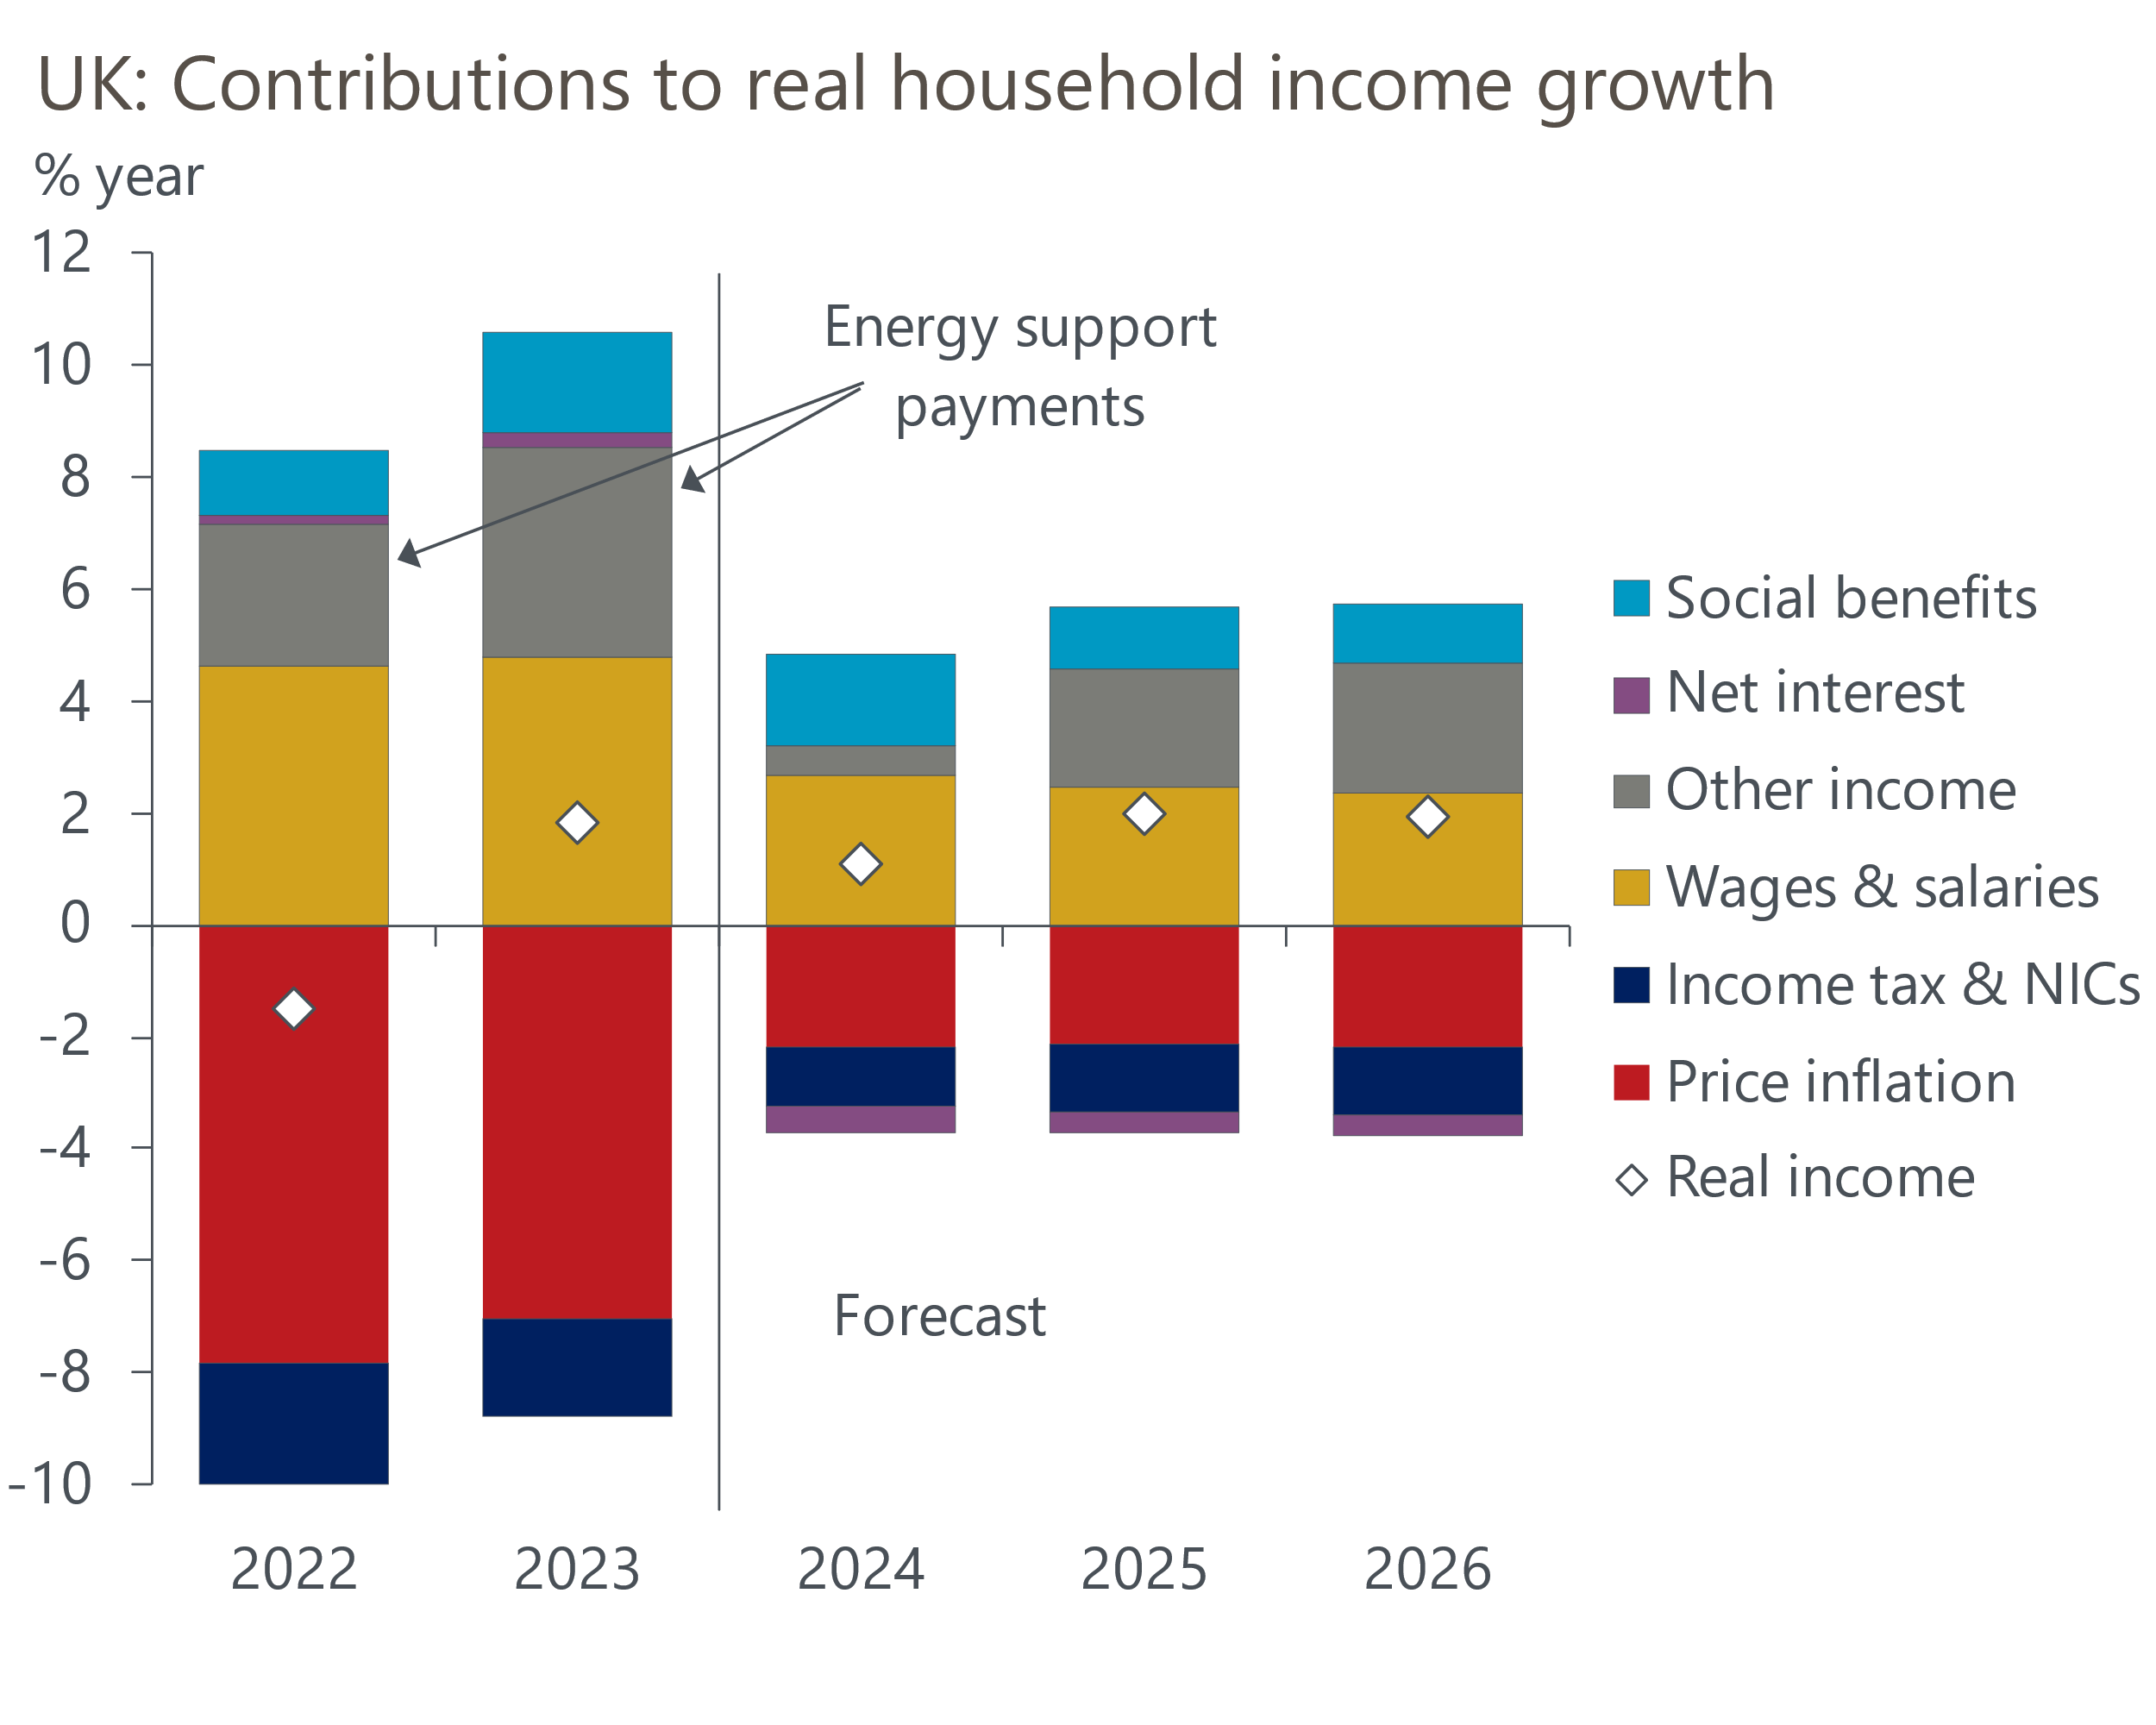
Sources: Oxford Economics, Haver Analytics

Above-inflation wage and benefit settlements to support household incomes
Reflecting a period of high inflation and historically tight labour market conditions in 2022 and 2023, nominal wage growth accelerated to soften the blow from inflation. Though pay growth slowed in H2 2023, inflation dropped more rapidly. As a result, following the deep squeeze on real wages, real terms pay has been rising since last summer, and we expect wages to consistently outpace inflation in 2024 and 2025.
On one side, steep falls in oil and wholesale gas prices, together with a softening in core pressures, means inflation is likely to fall back to the 2% target much quicker than we had anticipated last Autumn. On the other side, we expect the cooling in wage settlements to be much slower. Our proprietary sentiment-based wage nowcast, developed with Penta, suggests nominal pay growth has levelled off at a high rate in early 2024. This picture is broadly consistent with the results of the pay survey conducted recently by the Bank of England's regional agents.
Those lower down the income distribution stand to benefit the most – in April, the national living wage (for those aged 21+). will also rise 9.8%. Those out of work will also see their incomes boosted in April, when state benefits will be uprated by 6.7% and the state pension will increase 8.5%. Consequently, household incomes are set to consistently grow in real terms.

But the freeze on tax thresholds and allowances will continue to bite
However, some of the boost from strong real pay growth will be eroded by the ongoing impact of 'fiscal drag'. Most personal tax thresholds and allowances have been frozen in cash terms since April 2021 and are currently due to be frozen until the end of the 2027-2028 fiscal year. As nominal earnings have since grown significantly, this freeze has brought more people into higher tax brackets than would have occurred had thresholds continued to rise with inflation.
The cut in the rate of employee national insurance contribution rate cut that came into force in early-January will mitigate some of the impact. Specifically, the OBR estimates that the NICs cut will offset just over a third of the impact of fiscal drag in fiscal year 2024-2025, with this effect falling to just over a fifth in 2028-2029.
It's also possible that the Chancellor will announce further cuts to personal tax rates in his Spring Budget on March 6. But based on current policy, we forecast that the recovery in real post-tax salaries per employee in 2024 will quickly peter out in subsequent years because of the impact of fiscal drag (Chart 2).
Chart 2: Gross real wages look set for a recovery, but the outlook for post-tax incomes is more subdued
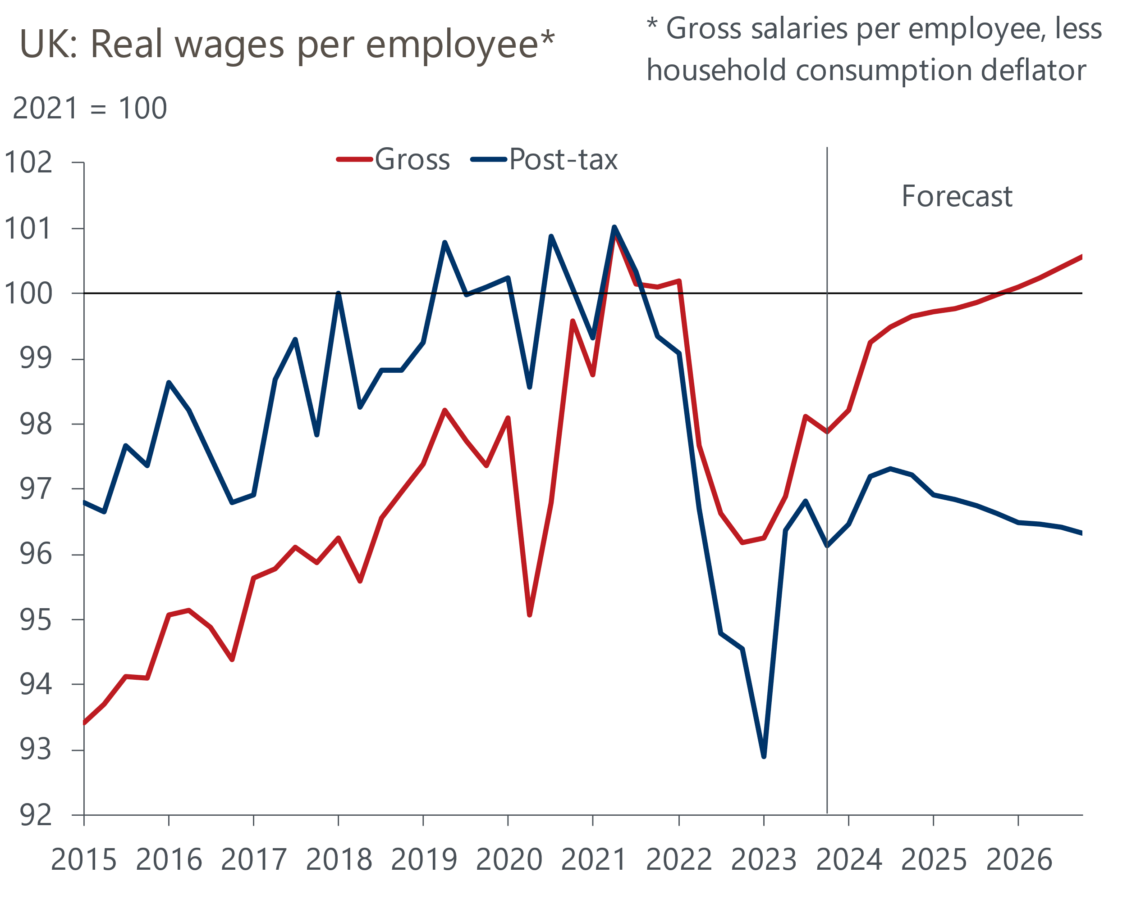
Source: Oxford Economics, Haver Analytics

Lower interest rates are unlikely to boost disposable income in the near-term
With CPI inflation now expected to return to the Bank of England's 2% target much earlier than previously expected, Bank Rate looks likely to be cut earlier than seemed likely just a few months ago. We now expect the first cut to come in June, with 75bps of rate cuts this year followed by 100bps in 2025.
But just the as popularity of fixed-rate mortgages slowed the passthrough of BoE rate hikes to average mortgage rates during 2022 and 2023, the same factor will also slow the transmission of cuts in Bank Rate to the average cost of home loans. Almost all of the 1.5mn mortgagors with fixed-rate deals expiring before the end of 2024 will face moving onto much higher interest rates when refinancing. The fall in quoted mortgage rates since mid-2023 has reduced the uplift in borrowing costs these mortgagors face, but we still forecast that personal sector debt interest payments will rise to 5.7% of disposable income this year from 5.1% in 2023.
In contrast, the transmission of tighter monetary policy to interest rates payable on household savings has been relatively quick. As a result, higher interest rates have so far been a net positive to household incomes. But savings rates are likely to respond equally quickly to Bank Rate cuts, so interest receipts are likely to fall sharply over the next couple of years. So we expect to move from a position where net household interest receipts made a positive contribution to real income growth of around 0.3ppts in 2023 to one where they drag by 0.5ppts this year (Chart 3).
Chart 3: Rising debt interest payments will increasingly weigh on disposable income growth
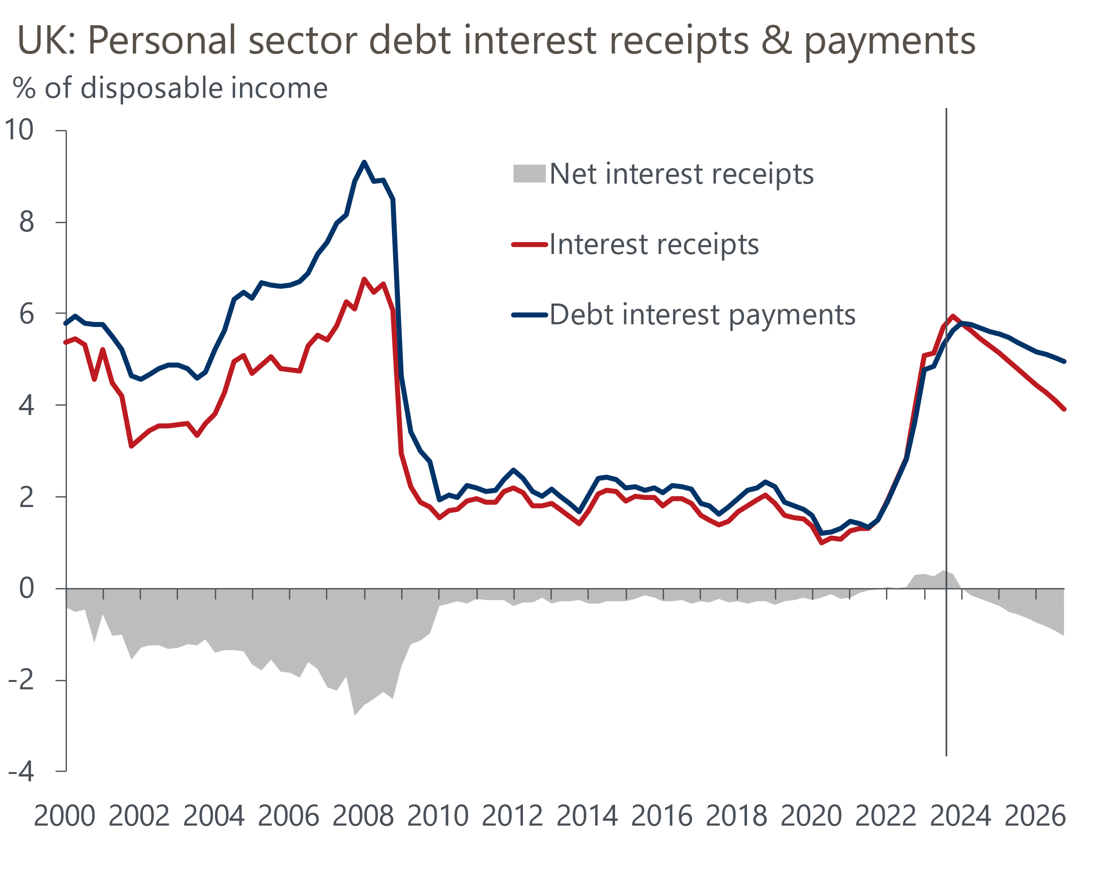
Source: Oxford Economics, Haver Analytics
But while net interest receipts are likely to weigh on real household disposable incomes on aggregate in 2024, this will conceal a significant divergence in outcomes across different groups. Two particular groups are likely to be losers from this year's events – mortgagors refinancing, who will face a large hit from a sharp rise in debt servicing costs, and those with savings in bank accounts.

Steadily improving real disposable incomes is just one-half of the consumption jigsaw
Bringing all of these factors together, we think real household disposable income growth is likely to slow to 1.1% in 2024, from 1.7% in 2023. But this is largely due to the loss of universal energy payments, which will mask steady growth in real incomes over 2024. As the distortion from the subsidy fades, we expect real income growth to accelerate to 2% in both 2025 and 2026.
Solid and sustained growth in household income should provide the foundation for a pickup in consumer spending over the next couple of years. The extent to which spending responds to firm income growth will depend on how household savings and credit demand evolve – a topic we will analyse in a separate note to be published later this week.

